Assignment for Image Recognition and Understanding

M5281954 WANG Binghao

1. environment:

Python3.8.1

opencv

2. Segmentation Algorithm:

Color gradient detection calculates the gradient in LAB color space, combines the gradient information of the three channels and uses Otsu thresholding. Brightness gradient detection uses the grayscale image to calculate the Sobel gradient and uses Otsu thresholding. K-means segmentation performs clustering in LAB color space and applies Canny edge detection to the segmentation results with an adjustable K value. Mean shift segmentation uses pyrMeanShiftFiltering to apply Canny edge detection to the segmentation results.

Use four methods: Color Gradients, Brightness Gradients, Color K-Means (K value is provided by the description on each page), and Mean Shift to detect five images. Change some parameters of each image and perform two. • Color gradient detection:

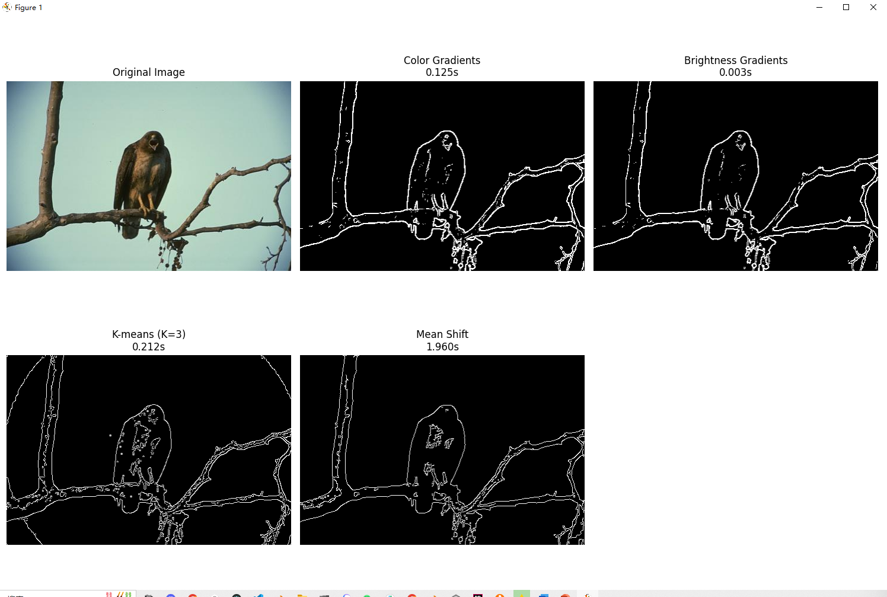

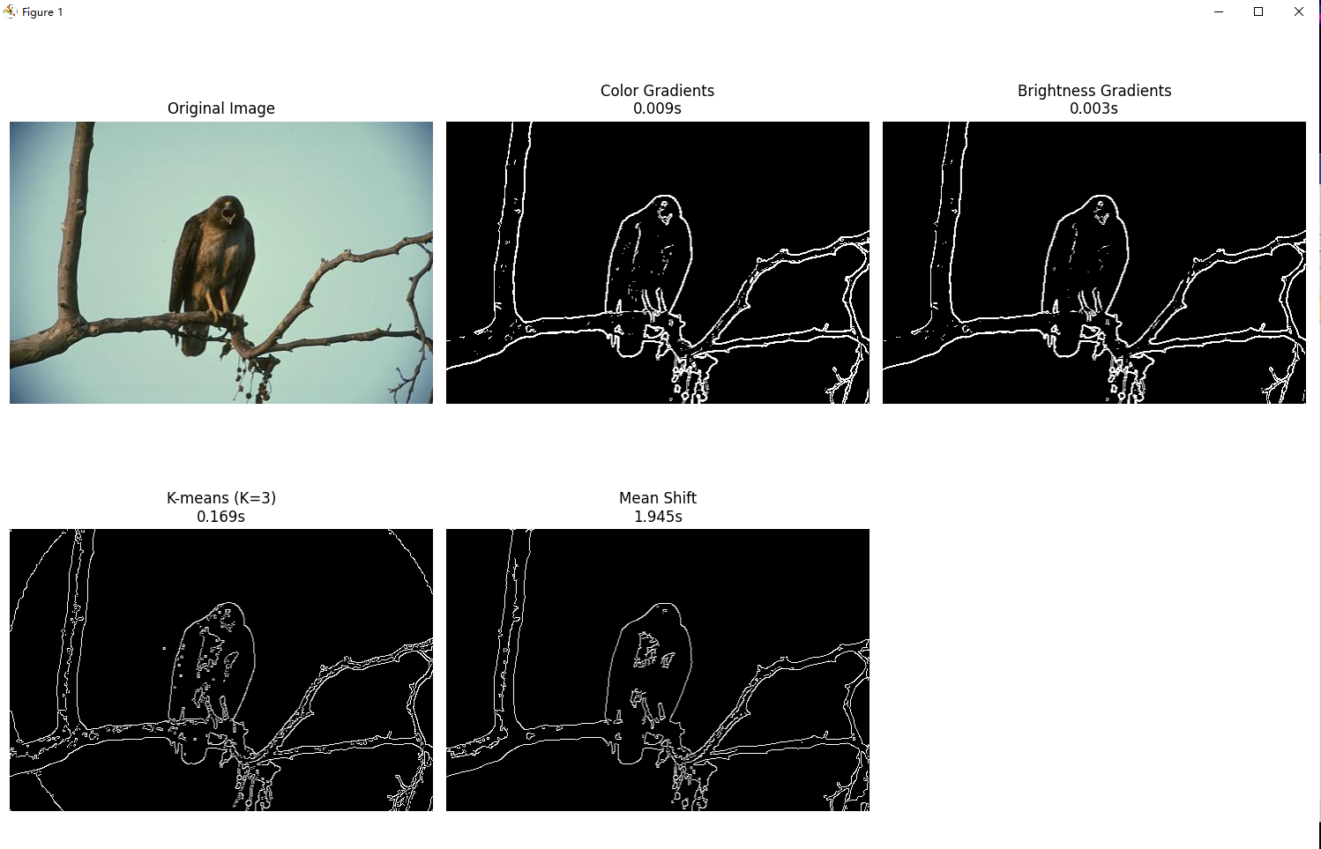

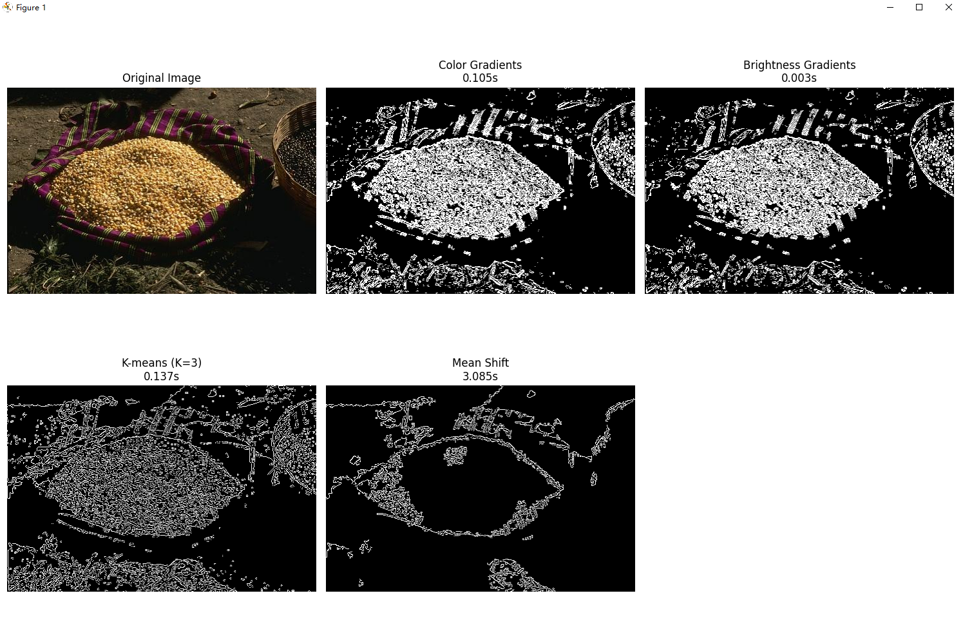

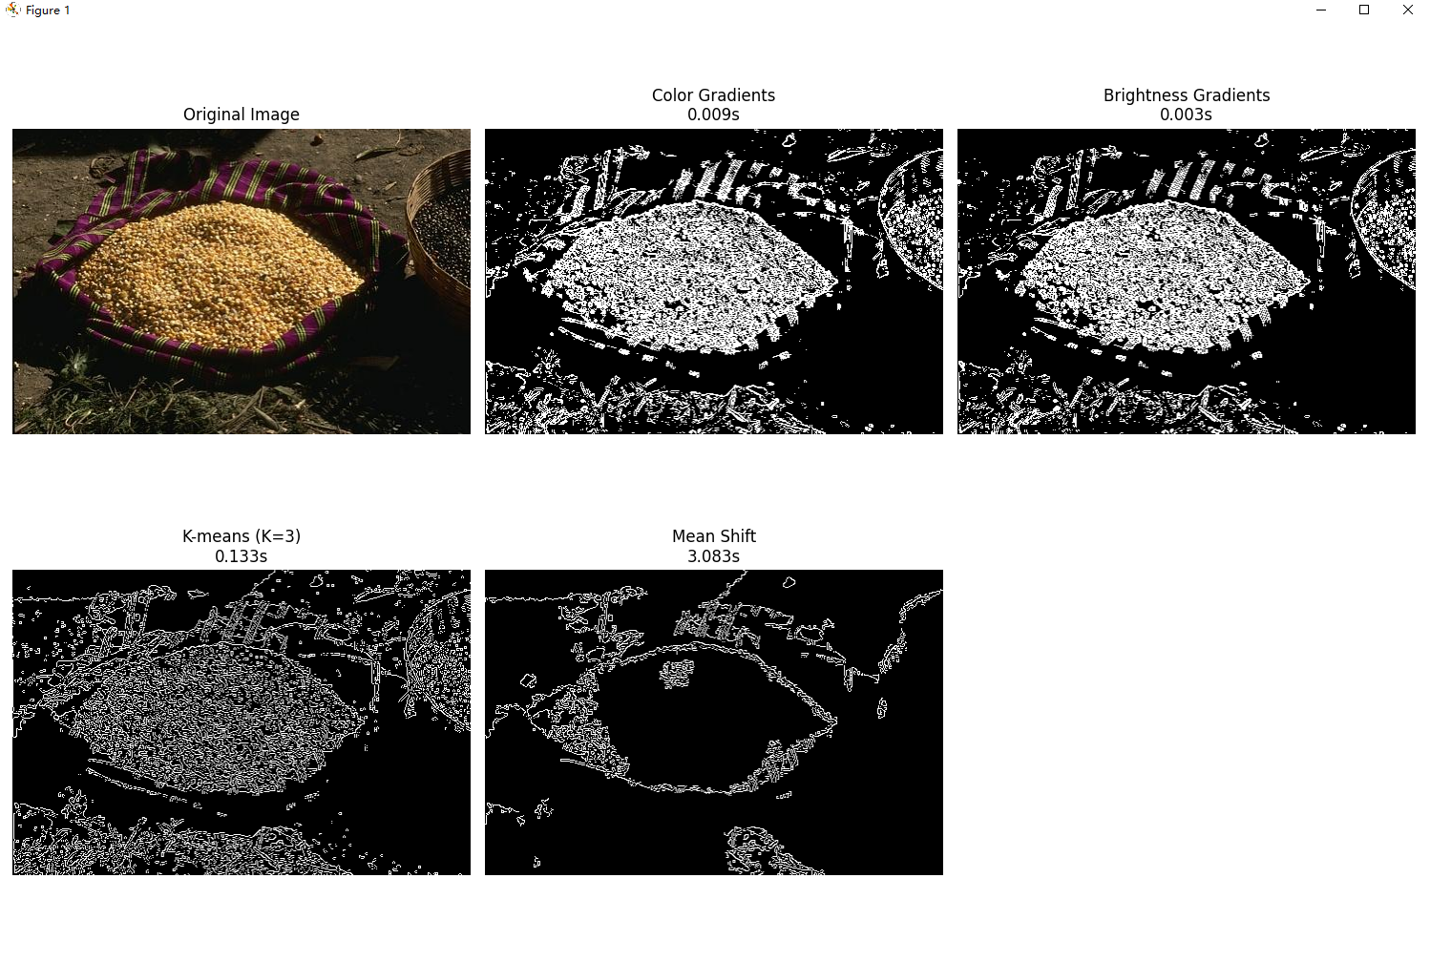

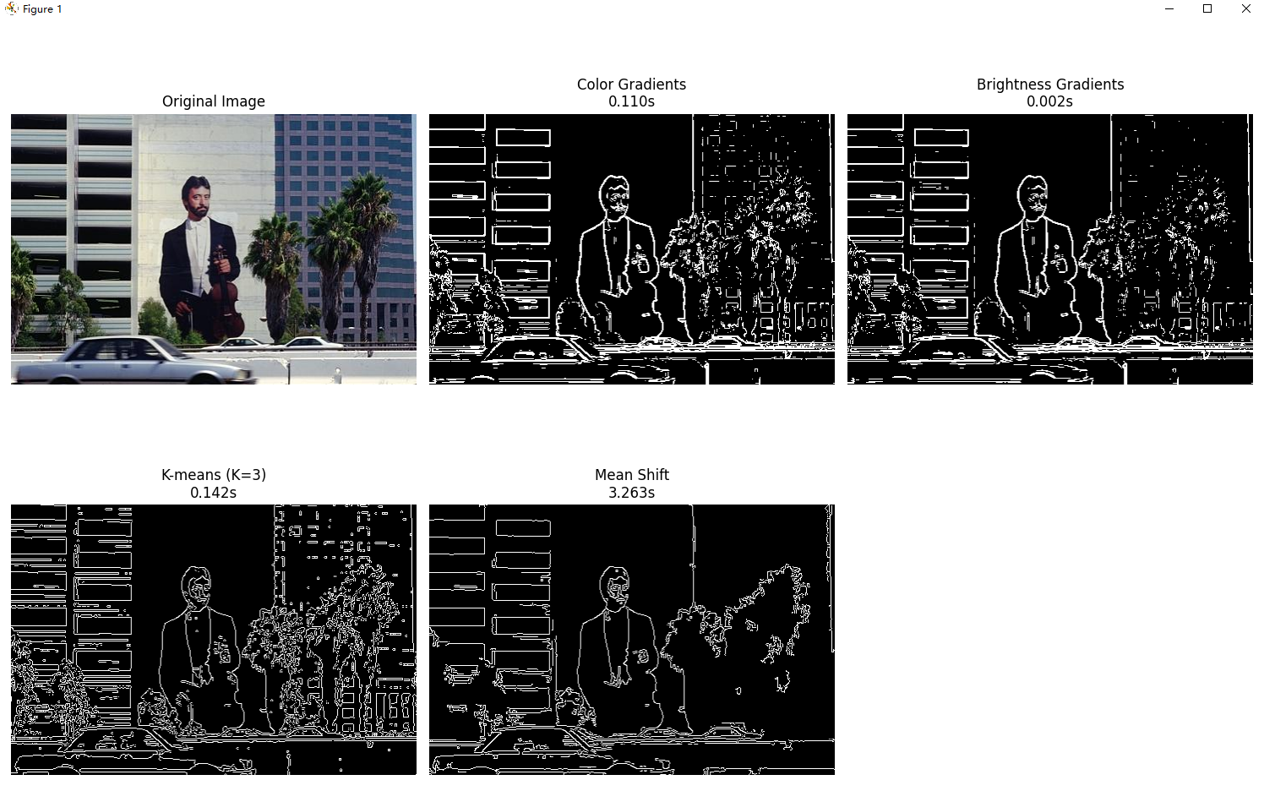

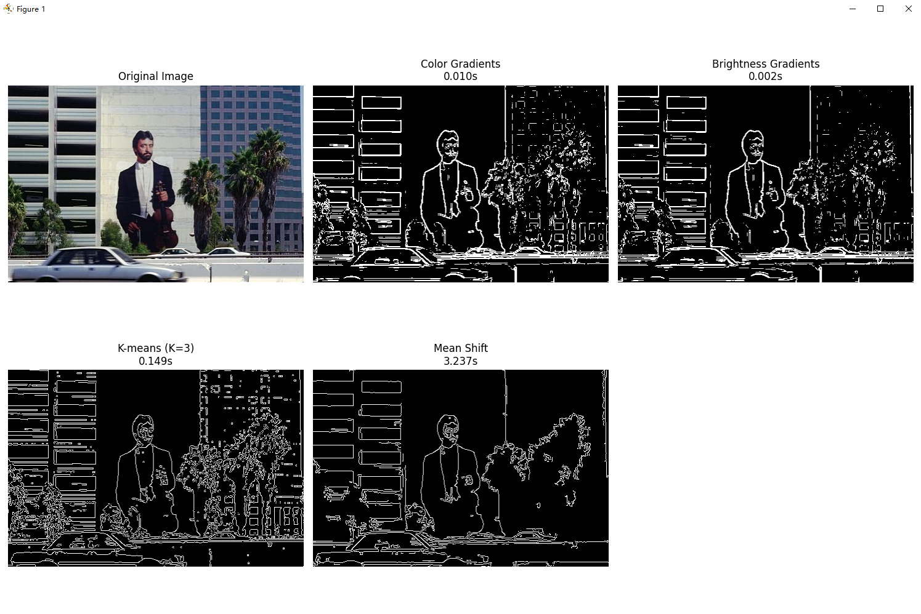

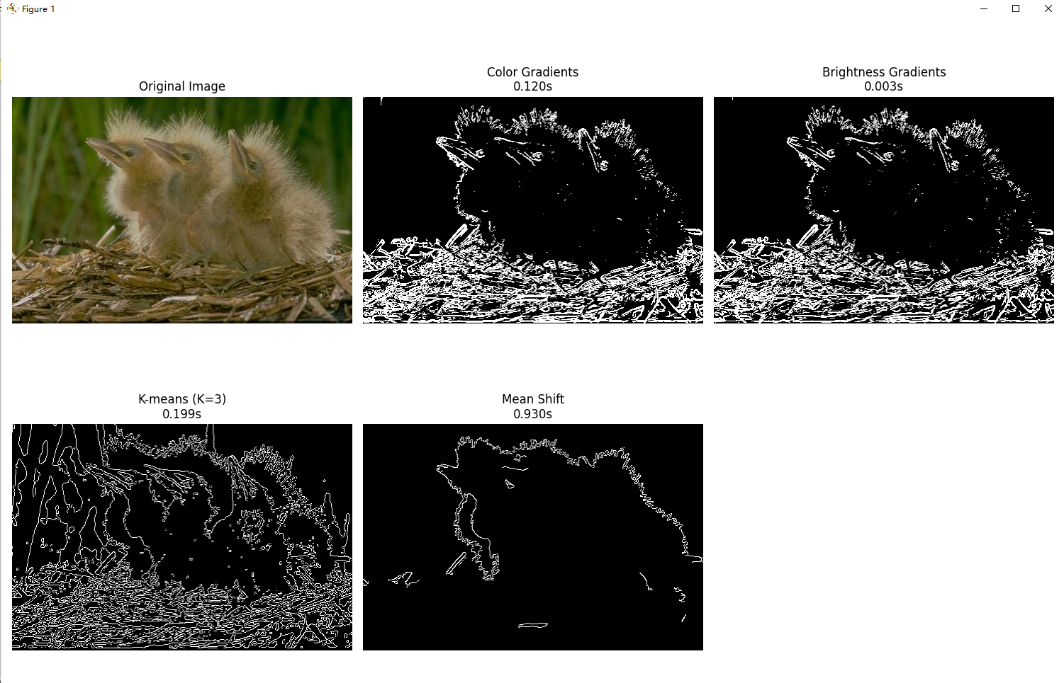

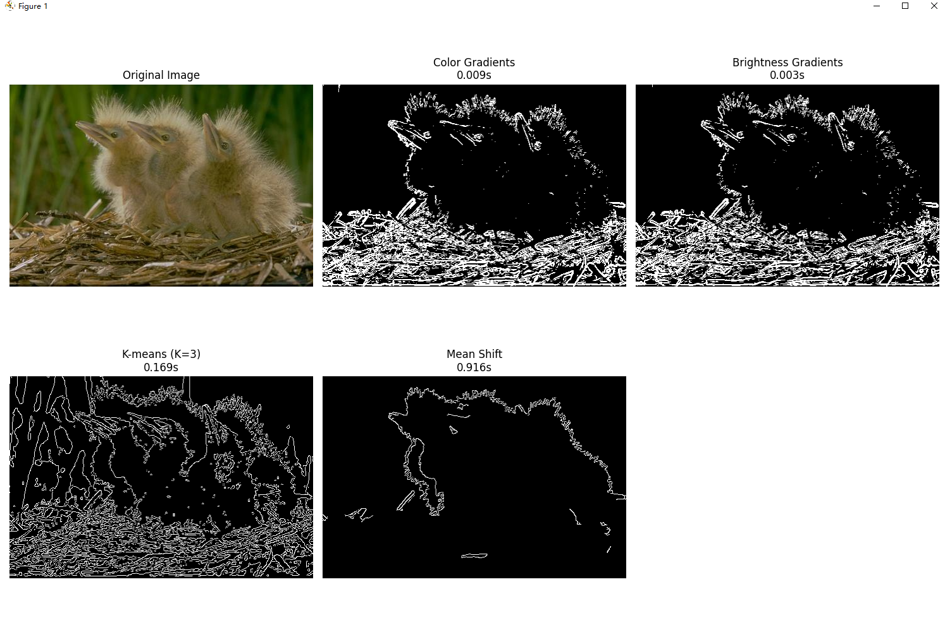

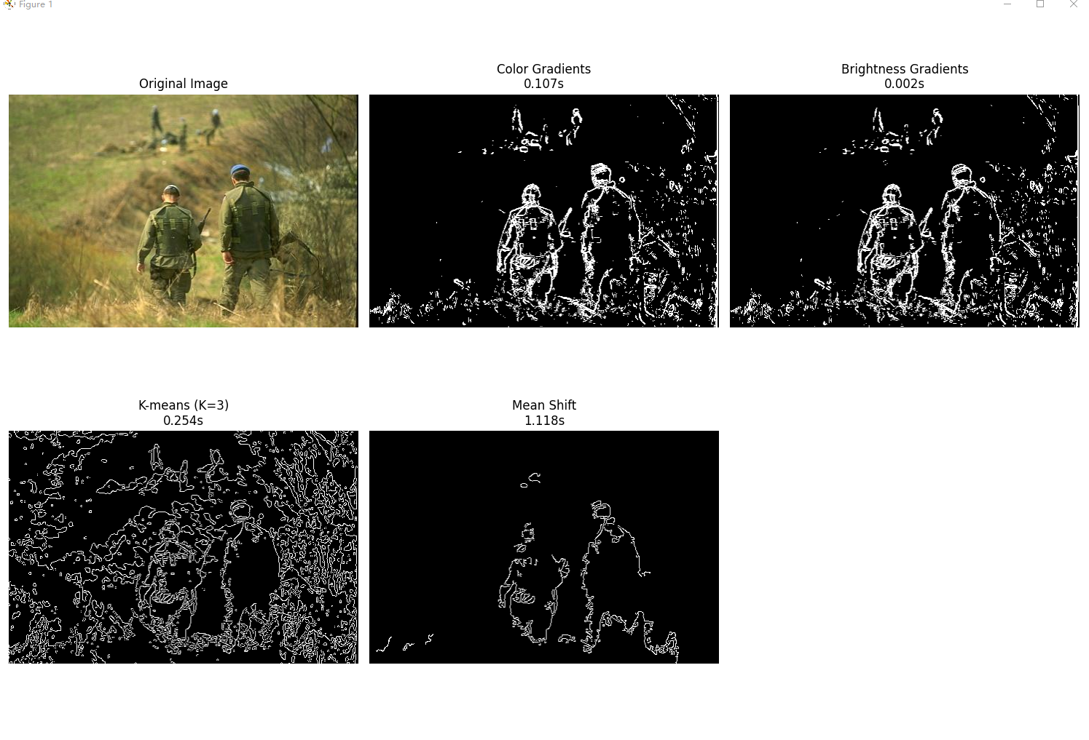

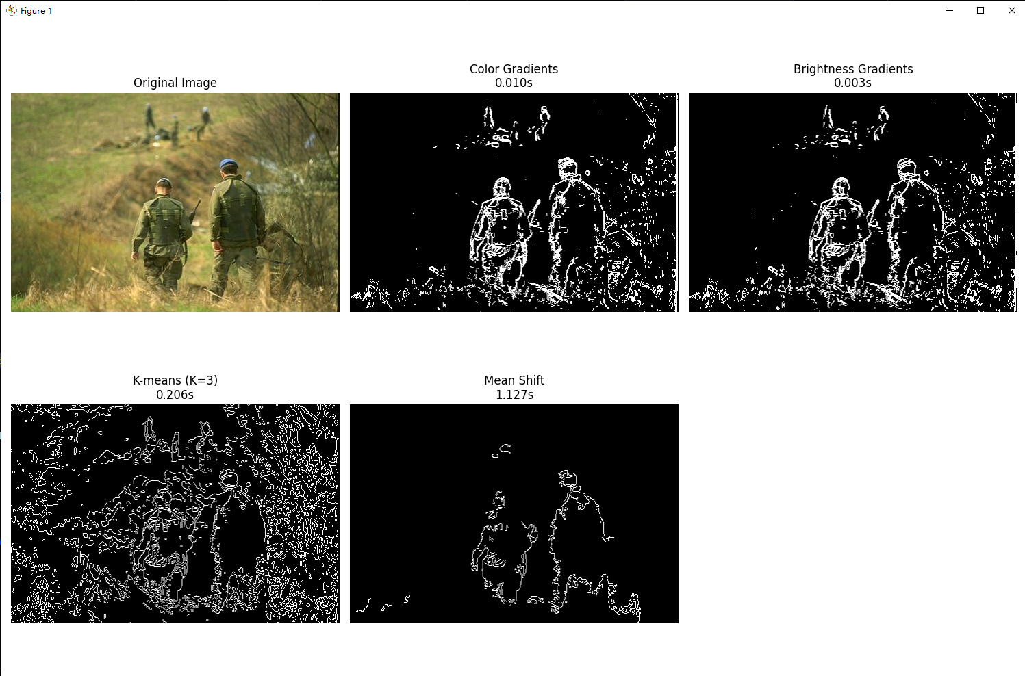

3.Evaluation Methodology:

Use Recall, Precision, and F-Measure to evaluate the segmentation effect. The following figure shows the evaluation during the processing, and more detailed evaluation parameters are also printed in the console.

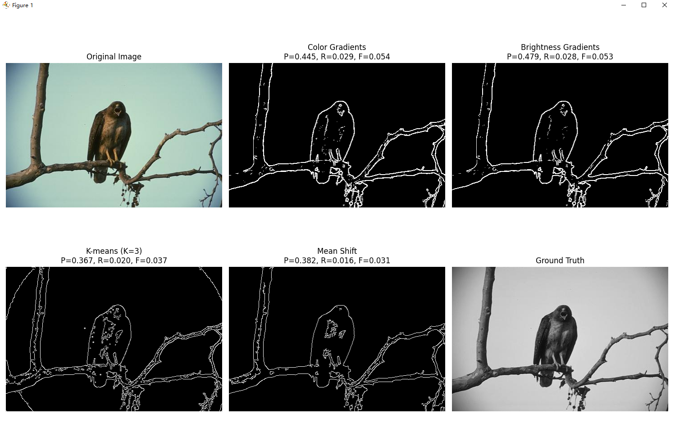

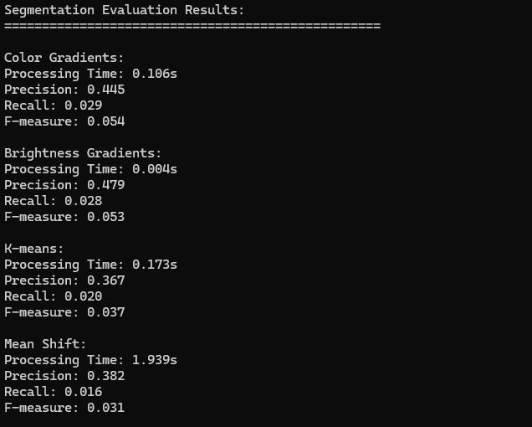

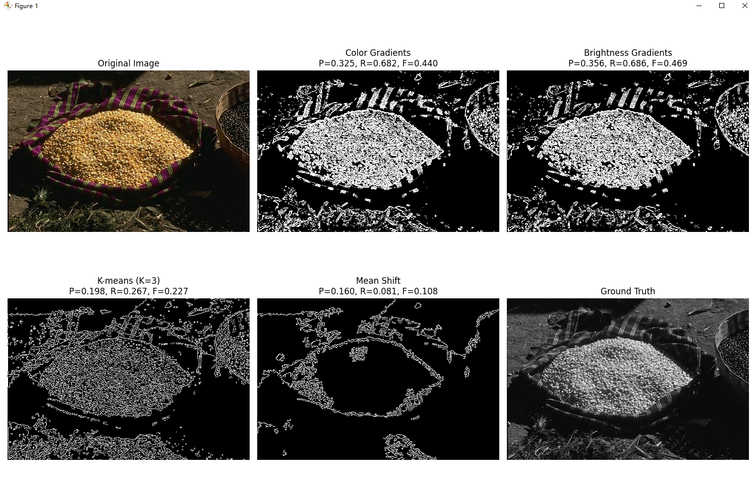

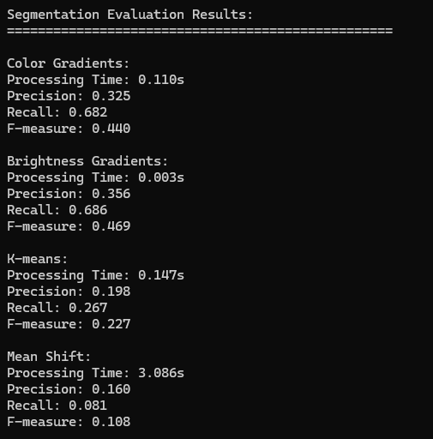

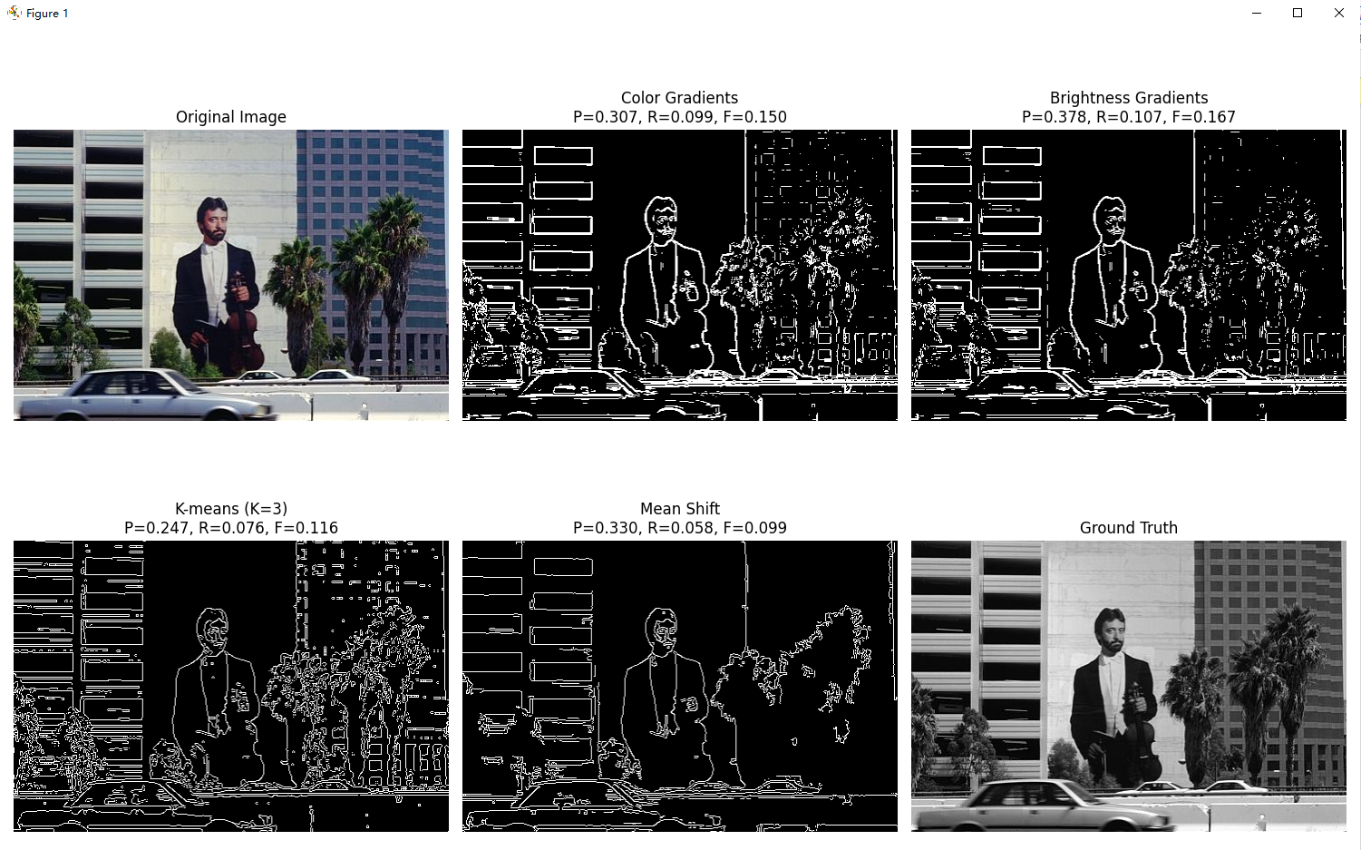

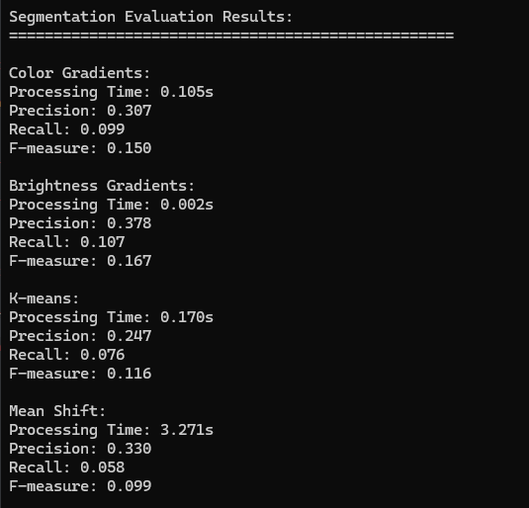

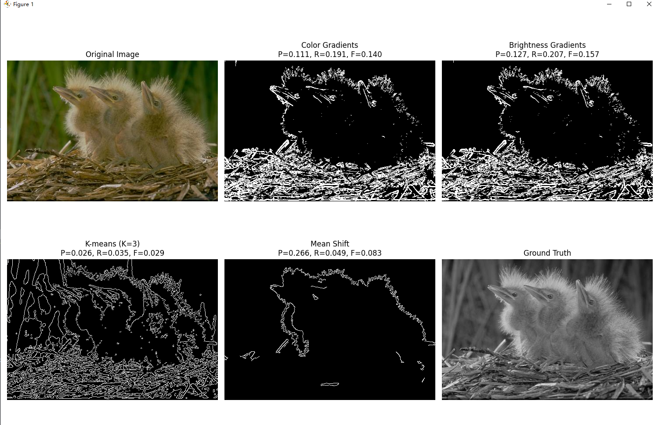

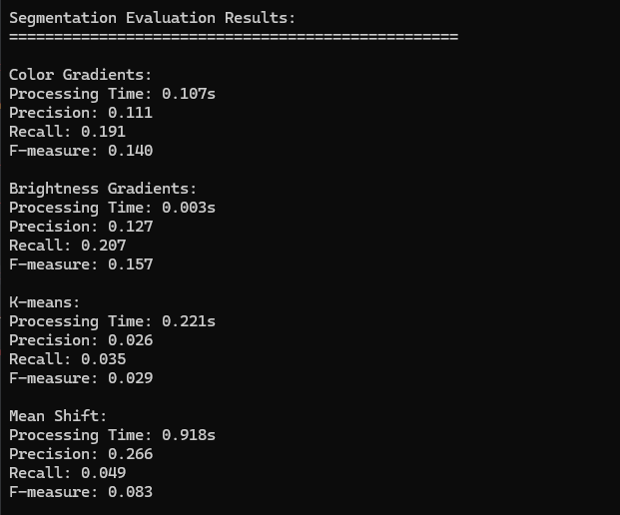

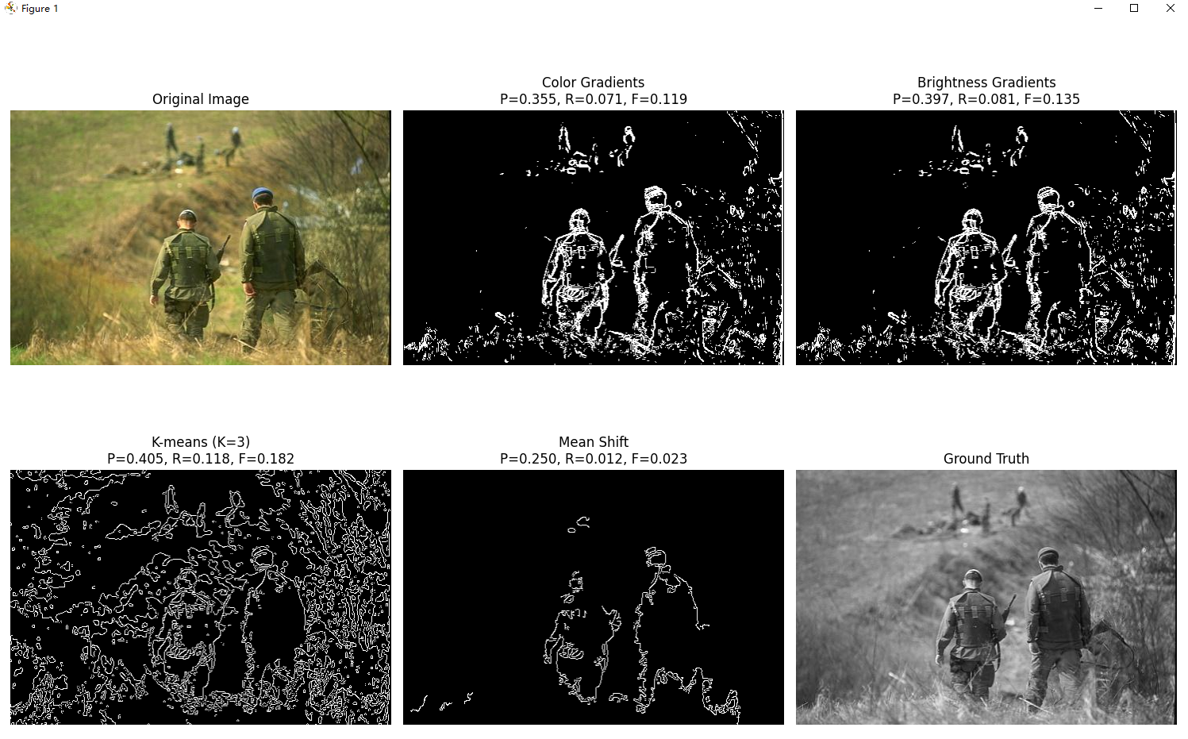

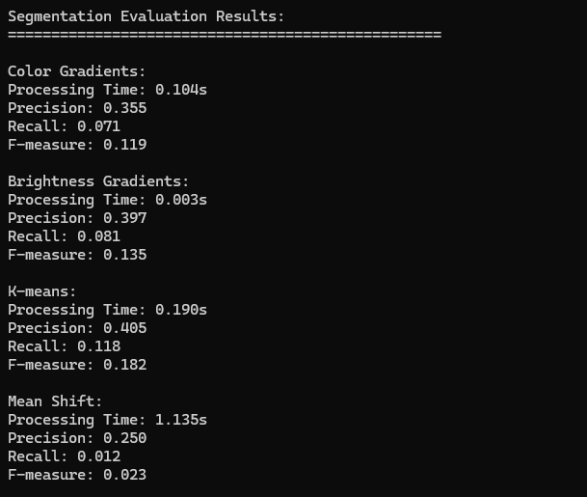

4. method analysis:

1. Color Gradients

Advantages:

• Capable of capturing boundaries of color changes

• Good effect on areas with strong color contrast

• Fast processing speed

Disadvantages:

• Sensitive to noise

• May produce false boundaries in color gradient areas

• Precision is generally low, indicating that over-detection is likely to occur

2. Brightness Gradients

Advantages:

• Simple calculation and fastest processing speed

• Good detection effect on obvious brightness boundaries

• High precision in some scenes

Disadvantages:

• Ignores color information

• Poor performance in areas with similar brightness but different colors

• Recall is relatively low, indicating that it is easy to miss detections

3. K-means segmentation

Advantages:

• Able to segment regions based on color features

• Good segmentation effect for large areas

• F-measure is relatively balanced and has good overall performance

Disadvantages:

• Need to pre-specify K value

• High computational complexity

• Results are affected by the initial cluster center

4. Mean Shift

Advantages:

• No need to preset the number of categories

• Can adaptively find the density center

• Good boundary preservation performance

Disadvantages:

• Longest computation time

• More complex parameter settings

• May over-segment in some cases

5.Comprehensive performance analysis:

1. Precision:

• K-means and Mean Shift generally have good precision

• Color Gradients has relatively low precision

2. Recall:

• Color Gradients usually have high recall

• Brightness Gradients has low recall

3. F-measure:

• K-means has good F-measure in most cases

• Mean Shift's F-measure is relatively stable